Question 1
20 / 20 pts
Please make sure to read and complete the entire set of steps before answering the question for each section.
Part 1
1. A good tech will not only learn the specifications of different CPU chips, but also will master the use of reference tools such as the Internet, manufacturer’s website, product documentation, and reference books. AMD Processor Specifications, https://www.intel.com/content/www/us/en/products/sku/212271/intel-core-i511400f-processor-12m-cache-up-to-4-40-ghz/specifications.htmlLinks to an external site. , https://www.intel.com/content/www/us/en/products/sku/236773/intel-core-i9-processor-14900k-36m-cache-up-to-6-00-ghz/specifications.htmlLinks to an external site. .
Fill in the table - Use the manufacture's websites to search for the solution
Maker (Manufacturer) | CPU Type and Version | Package (Socket) | Max Clock Speed (GHz) | Max Wattage consumption (TDP) | Cache (as listed by manufacturer) | Number of Cores
AMD | Ryzen ThreadRipper 5995WX
AMD | Ryzen 7950X
Intel | Core i5-11400F
Intel | Core i9-14900K
Your Answer:
Maker (Manufacturer) | CPU Type and Version | Package (Socket) | Max Clock Speed (GHz) | Max Wattage consumption (TDP) | Cache (as listed by manufacturer) | Number of Cores
AMD | Ryzen ThreadRipper 5995WX | sWRX8 | 4.5 GHz | 280 W | 288MB | 64 Cores/ 128 threads
AMD | Ryzen 7950X | AM5 | 5.7 Ghz | 170 W | 80 MB | 16 Cores
Intel | Core i5-11400F | FCLGA 1200 | 4.40 Ghz | 65 W | 12 MB Intel® Smart Cache | 6 Cores
Intel | Core i9-14900K | FCLGA 1700 | 6.0 GHz | 125 W- base 253W Turbo | 36 MB Intel® Smart Cache | 24

Question 2
20 / 20 pts
2. Examine two CPUs (Do not use the ones in Question 1), released within the past two years, that you find on the Internet (one AMD and one Intel). Provide the screenshot of each CPU's specifications. From the specifications provide the following information in addition to the screenshots.
- Which CPU is the fastest?
- Which CPU has the largest amount of cache?
- Which CPU has the most cores?
- Which CPU would you choose if you were building a gaming machine and why?
Your Answer:
AMD Ryzen™ 9 9950X
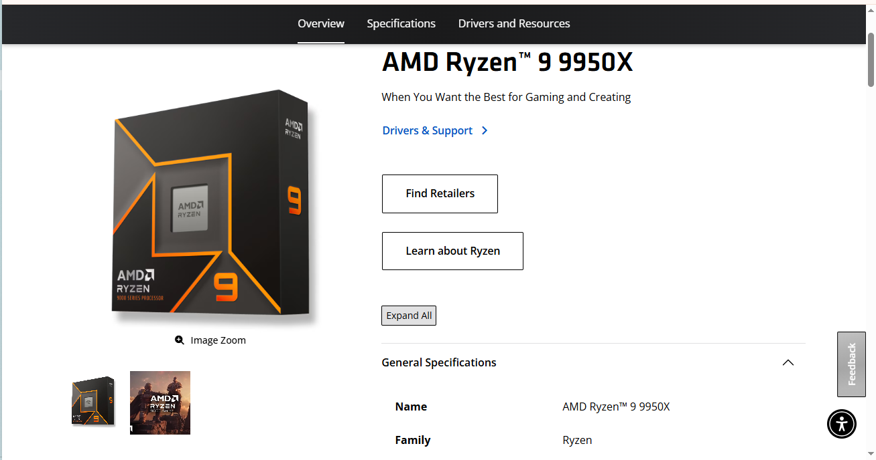
Intel core i7 14700K
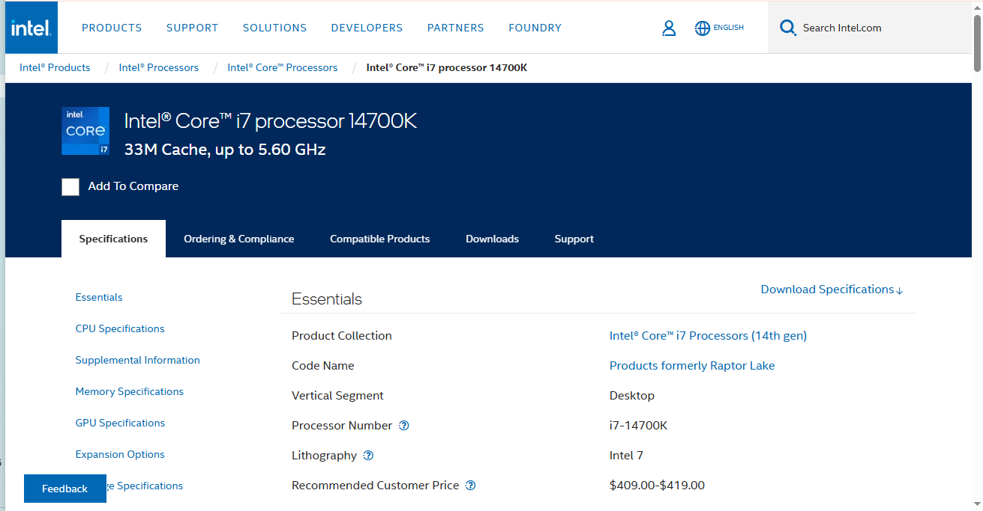

Comparison
- Fastest CPU: AMD Ryzen 9 9950X (up to 5.7 GHz)
- Largest Cache: AMD Ryzen 9 9950X (80 MB total cache)
- Most Cores: Intel Core i7-14700K (20 cores)
- Best for Gaming: AMD Ryzen 9 9950X — higher boost clock and superior single-core performance

Question 3
10 / 10 pts
Part 2
1. Selecting a Replacement Power Supply
Only do one of the following: (If you are going to use a desktop PC please use it for all following questions, if you use a laptop then use that for all following questions.)
For a Desktop PC, to determine the wattage rating of your power supply, remove the case cover and look at the label on the power supply.
OR
If you have a laptop, look at the brick attached and record the wattage rating from its labeling.
What is the wattage rating of your power supply or brick? ______________
Your Answer:
Wattage rating of my laptop brick: 45W

Question 4
20 / 20 pts
2. Selecting a Replacement Power Supply
When it comes time to replace a power supply, do not skimp on the wattage! As a rule, get the highest wattage replacement you can afford while maintaining compatibility with your system. Remember the system will only draw what it needs, so you will never damage a system by installing a higher wattage power supply. Remember only add the actual components you have in your computer system.
Calculate for the system you chose in Question 3.
For Desktops, If it is a brand name then use the specifications from that website using the Model name and number from manufacturer's website. If it is custom built you can catalog the parts you have and use the averages below for each part.
For Laptops, If it is a brand name then use the specifications from that website using the Model name and number from manufacturer's website. Then use the lower wattage for each component it lists unless you know the actual wattage from the specifications list.

Component | Requirement | Voltage(s) Used
Video Card  Look up the cards power consumption from the web site (if you can’t find a video card ignore this) | 60 to 350W (Avg 208W) | Mostly 12V
PCIe Expansion card (Only add this if you can identify one) | X1: 10W per card  X4, X8, X16: 25W per card | 3.3V and 12V
Solid State Drive (assume that you have one) | .6 to 2.7W (Avg 1.65W) | 5V
Hard Disk Drive (Only add if you can identify one) | 2.5”: .7 to 3W (Ave 1.85W)  3.5”: 6.5 to 9W (Avg 7.75W) | 5V and 12V
Optical Drive (Only add if you can identify one) | DVD: 15 to 27W (Avg 21W)  Blu-ray: 25 to 30W (Avg 27.5W) | 5V and 12V
Case / CPU fans | 0.5 to 6W each (Avg 3.25W) | 12V
Motherboard | 25 to 40W (Avg 33W) | 3.3 and 5V
RAM | DDR3: 3W per stick  DDR4: 2.4W per stick | 3.3V
CPU – look up your model of CPU (Intel or AMD) | Varies by model: 55 to 200W Desktop (Avg 128W)  Laptop (Avg 65W) | 12V
3. Estimate the wattage your system uses by identifying any components you can, then add the average (Avg) wattage together of those pieces together. (Note: Laptops will fall on the low end of the wattage for components as they are designed to save power.)
Based on what you calculated from your system, what power supply wattage should you purchase if you needed to replace your existing power supply (Desktop) / brick (Laptop) for your computer? _______________________ Watt(s)
Your Answer:
Based on the components in my HP Laptop 15-bs0xx, the estimated power usage is as follows:
- CPU (Intel Core i5-7200U): 15W
- Motherboard: 25W
- SSD: 0.6W
- RAM: 2.4W
- Fan: 0.5W
Total Estimated Wattage: 43.5W
Therefore, if I needed to replace my existing laptop power brick, I would choose a 45-watt power supply.

Question 5
10 / 10 pts
4. Shop online to find a replacement power supply with the adequate wattage for your desktop:
Only choose the system you used in question 3.
Write down the specifications for the best power supply that would meet your system needs (for desktops only): (Order the answers as below.)
- Upload a screenshot of the power supply product page. Use Insert > Image > Upload Image and find and select the picture you took for this question.
- Uses PFC? (Yes/No): _______________
- 80% efficiency at up to 100% rated load (Yes/No)? ____
- Correct form factor (Size) (Yes/No)?_____
- Has correct drive power connectors for internal devices(Yes /No)?______
- Correct power connectors to supply the motherboard's power needs? (Yes/No)_____
OR
If you used the Laptop as the system in Question 3: (Order the answers as below.)
4. Shop online to find a replacement power supply brick with the adequate wattage for your laptop:
- Upload a screenshot of the power supply product page. Use Insert > Image > Upload Image and find and select the picture you took for this question.
- Website of Vendor where you found the replacement: ___________________________
- Price of the replacement power brick: ___________
- Wattage: ________
Your Answer:
Website of Vendor where I found the replacement: HP Official Store (https://www.hp.com)
Price of the replacement power brick: $53
Wattage: 45W
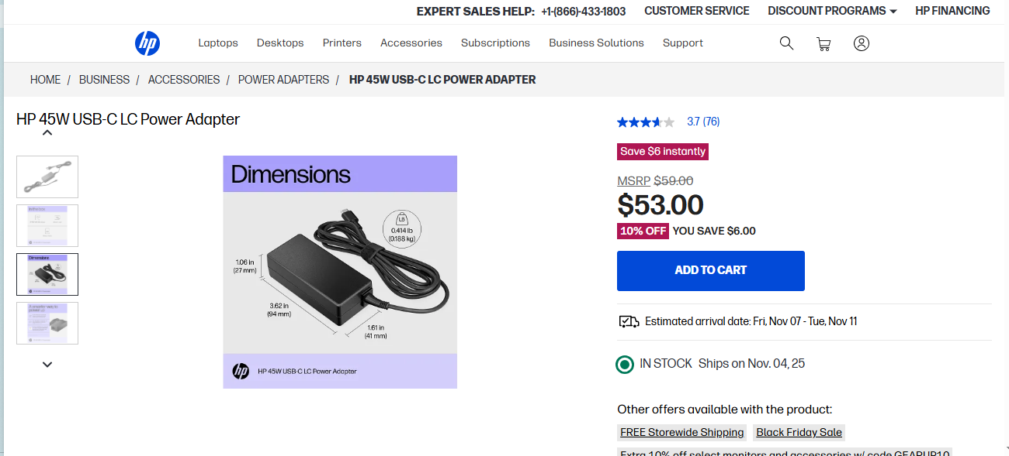

Now, let's look at how AI can help in the computer building process and see if what it gives us as advice will work for the things we want to do with it.
As technicians we need to realize that AI is seeping into almost everything we do. However, we need to realize that AI is a tool, and it does have its failings. So, when we use it, we do need to verify that what it suggests will work by evaluating what it gives us. That will take us knowing what the individual pieces are that go into a successful desktop computer build.
For now, we will look at the list AI gives us and see if we can spot anything that might not work based on what we know and can research.

Question 6
5 / 5 pts
AI as a tool in building your own PC:
1. Now let's go to Chat GPT for our exercise: https://chatgpt.com/Links to an external site.
2. If you don't have an account already go ahead and use the Sign up for free button on the site.

3. Once you have an account login.
4. Let's try a simple prompt. Type: "Suggest a list of Personal Computer parts that I would need to build a low-budget computer to play most current games." into the AI prompt.
5. Paste what you get from the AI in the box below:

Your Answer:
Suggested list of Personal Computer parts for a low-budget gaming build:
- CPU: AMD Ryzen 5 5600 or Intel Core i5-12400F
- GPU: NVIDIA GeForce RTX 3060 or AMD Radeon RX 6600
- Motherboard: B550 (for AMD) or B660 (for Intel) chipset motherboard
- RAM: 16GB DDR4 (2x8GB, 3200MHz)
- Storage: 1TB NVMe SSD
- Power Supply (PSU): 550W 80+ Bronze certified
- Case: Mid-tower ATX case with good airflow
- Cooling: Stock CPU cooler (included) or a budget air cooler if needed
- Operating System: Windows 10/11 Home
- Monitor: 1080p 144Hz gaming monitor (optional but ideal)
This setup balances price and performance, allowing smooth gameplay in most modern games at 1080p resolution.

Question 7
5 / 5 pts
6. Interesting, isn't it? You should have gotten a good list of items to look into. Check out some of the things on the list to make sure they exist. We have to be careful that AI is not giving you any information that is incorrect or made up.
7. Did you find anything on the list that was incorrect when you looked those parts up?
8. Paste a screenshot of 2 different items you investigated (1 screenshot for each item).
Use Insert > Image > Upload Image > and select each screenshot you saved to upload them.
Your Answer:
No, all the listed components such as the AMD Ryzen 5 5600 processor and NVIDIA GeForce RTX 3060 graphics card are real and available on multiple retailer websites like Amazon and Newegg. The information provided by AI was accurate.

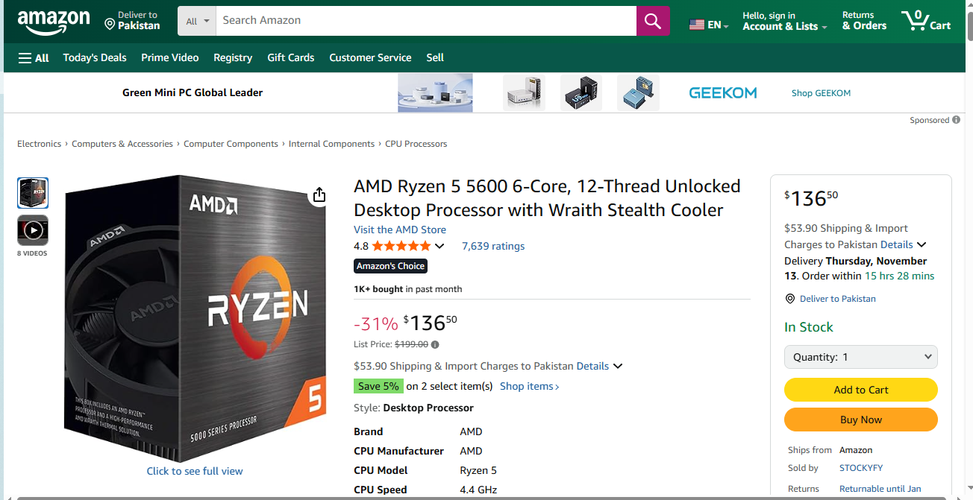
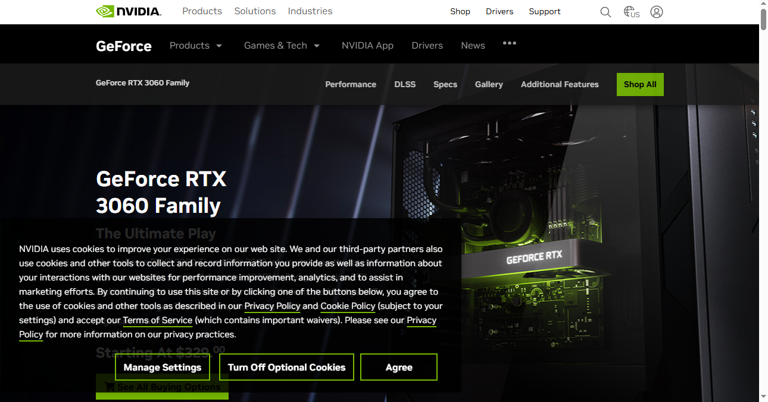

Question 8
5 / 5 pts
9. Now let's have Chat GPT find prices for us on these parts it suggested. Enter the additional prompt into the AI interface: "get me current pricing on the suggested items in the list".
10. That's amazing isn't it! Take a look at the results and take a screenshot of them.
Use Insert > Image > Upload Image > and select the screenshot you saved to upload them.
Your Answer:
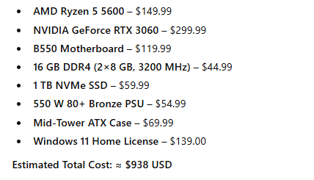

Question 9
5 / 5 pts
11. Ok one last question. As you follow the links it gives you are there any that don't work or are incorrect? (answer only one of the questions that follow based on the results)
If so, which ones were they? (answer below in the textbox)
OR
If not, then answer whether you feel the suggestions to be a good deal and if there is anything you might change. (answer below in the textbox)
Your Answer:
No, all the links worked correctly. The suggested parts and prices seemed accurate and reasonable for a low-budget gaming build. Overall, the deals were good, though I might upgrade the GPU to a slightly newer model like the RTX 4060 for better future performance if the budget allows.

Summary
Well, that should do it. You now have some resources to work with that can help you understand and gage CPUs, Power supplies and what you might need to know about them.
Plus, now you have a tool (Chat GPT or any AI for that matter) that could help you if you wanted to try to build a PC of your own. It won't always be correct so you should still check out the part you plan to get before buying it, but it can make the process easier.
If you want some extra fun, try telling it what you would like the PC to be able to do and see how its recommendation

