Week 2 - Hands On Exercise 03 Results

Score for this attempt: 100 out of 100
Submitted Nov 15 at 9:44pm
This attempt took 3,079 minutes.

Question 1
16 / 16 pts
Please make sure to read and complete the entire set of steps before answering the question for each section.
Part 1
Open and follow the instructions in this Lab sheet: Teardown lab for Dell Pro Tower QCT1255 -New.pdfDownload Teardown lab for Dell Pro Tower QCT1255 -New.pdf
Once finished take a picture of the motherboard in the case and upload it.
Use the Insert > Image > Upload Image then choose the picture you saved.
Your Answer:
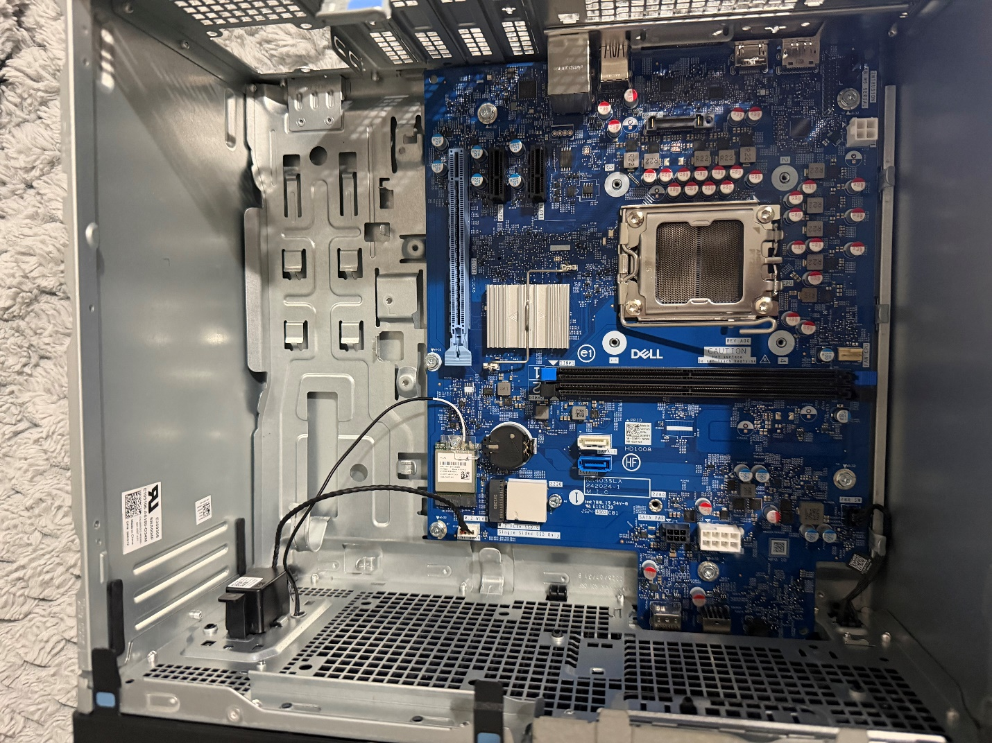

Question 2
7 / 7 pts
Part 2
The CPU:
- Go to https://www.dell.com/support/home/en-usLinks to an external site. and enter the service tag number that can be found on the Dell tower (usually on top of the case denoted by ST: XXXXXXX). Select the Quick links > Review specifications link and look for the CPU (Will be denoted by i5 and Intel key words or Ryzen 5 and a 4-digit number.)

Examine your CPU:
- Did your CPU come with a CPU Heatsink and Fan: (yes/no)
- How fast does the processor say it is? ______________
- What is the Generation of your Intel/AMD CPU and how do you know this? ______________
- Is your CPU an LGA or a PGA and explain how you know which it is? ________
- (For Dell Systems) What is the Service Tag number? ______________
Write down the CPU version number (Ex. i5-12500 or Ryzen 5 85XX)
Your Answer:
1. Did your CPU come with a heatsink and fan?
Yes

2. CPU speed:
Up to 5.0 GHz

3. CPU generation & how I know:
8th Generation AMD — the “8” in 8500G shows the generation

4. LGA or PGA & how I know:
LGA — AM5 CPUs use LGA, where pins are on the motherboard

5. Dell Service Tag:
7YNYMD4

6. CPU version number:
AMD Ryzen 5 PRO 8500G

Question 3
7 / 7 pts
Look up your processor on the manufacturer’s website (Intel / AMD):.https://www.intel.com/content/www/us/en/homepage.htmlLinks to an external site. (Intel) or https://www.amd.com/en/products/Links to an external site. (AMD) or here https://cpu.userbenchmark.com/Links to an external site. (for either Intel or AMD)
- How many cores does it have? _________
- How much cache does it have (Note: This is the level 3 cache.) ____________
- Does this CPU come with a built in GPU and what processor graphics is it? ___________
- What Memory types does it support? __________
- What is its Thermal Design Power (TDP or CPU power rating)? ___________
- What CPU socket does it support? _______________
- Take a screenshot of the CPU’s product page form its website and insert it into the answer area.
Use the Insert > Image > Upload Image then choose the picture you saved.
Your Answer:
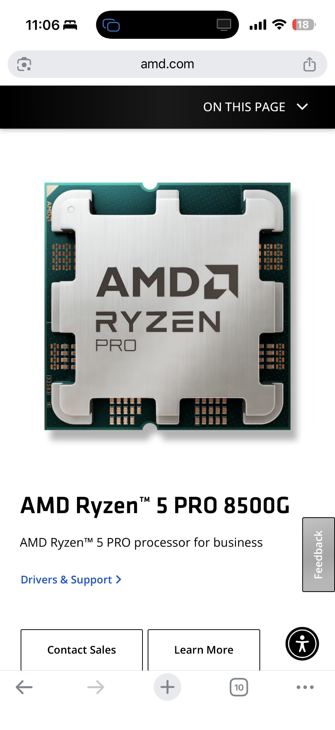1. How many cores does it have?
6 cores

2. How much L3 cache does it have?
16 MB L3 Cache

3. Does it have a built-in GPU? If yes, which one?
Yes — AMD Radeon™ 740M Graphics

4. What memory types does it support?
DDR5 (AM5 platform)

5. What is its TDP (power rating)?
65W TDP

6. What CPU socket does it support?
Socket AM5

Question 4
7 / 7 pts
Part 3
The Motherboard:
To get the Dell service manual go to https://www.dell.com/support/home/en-usLinks to an external site. and enter your service tag number. It should be a combination of about 7 numbers and letters. Select Documentation and look under Manuals and Documents. The access the PDF for Dell Pro Tower QCT1255 Owners Manual.
(Example Only)

Take a screenshot of the rear of the PC and save it as a file. Use the Insert > Image > Upload Image then choose the picture you saved.
Your Answer:
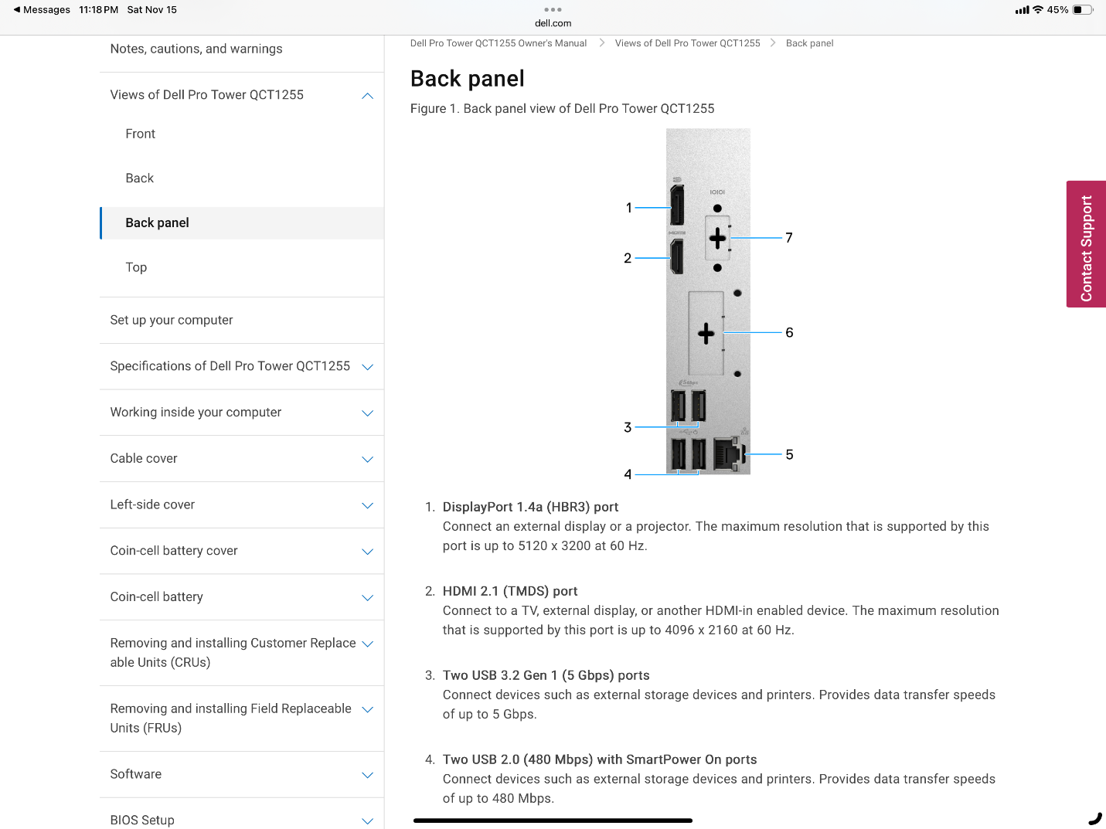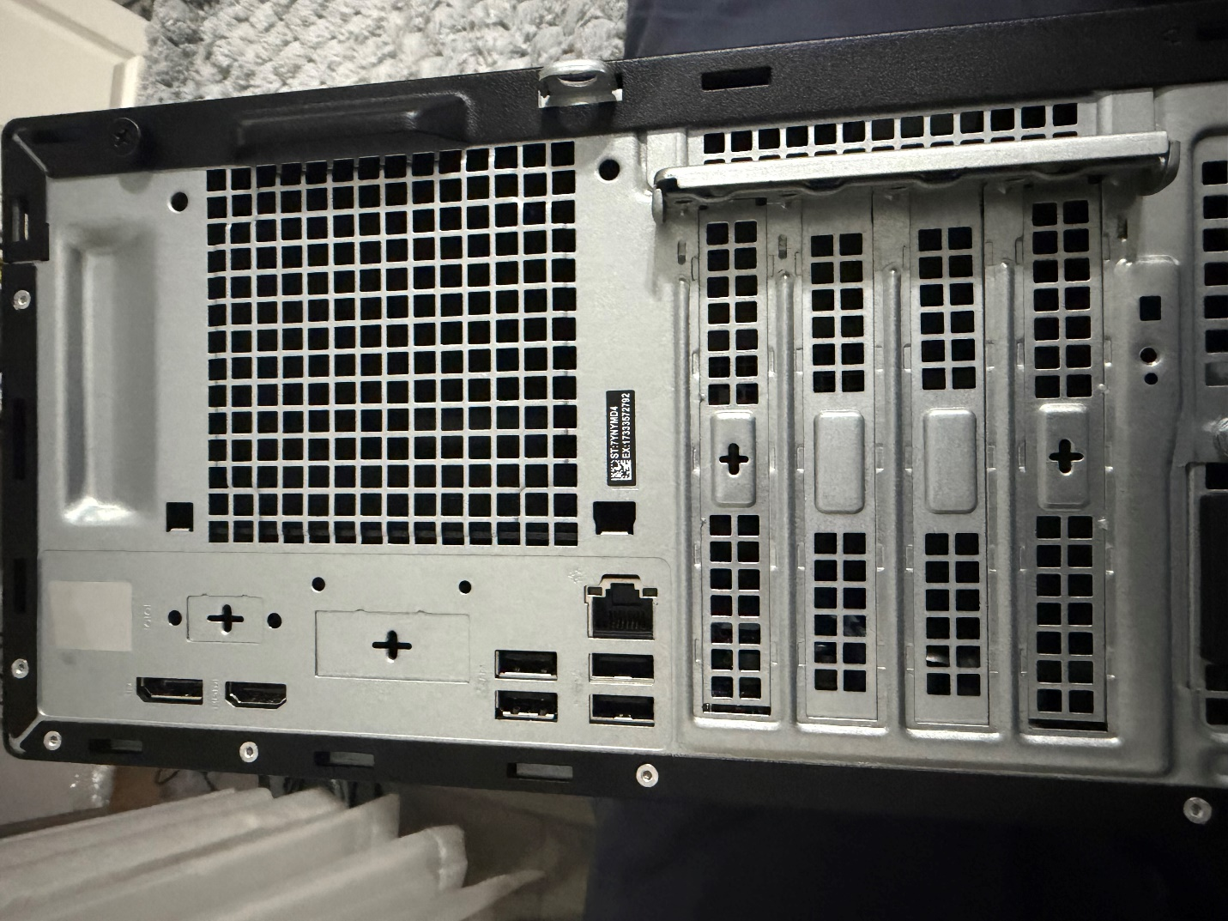

Question 5
7 / 7 pts
Examine the motherboard and identify if these ports are and how many are on your motherboard (You can use the Dell’s product specs or owner’s manual as well to help identify): (If it is not specified put N/A for the answer.)
a. USB 2.0 ______ (Yes/No, and How Many if Yes?)
b. USB 3.0 (3.1, 3.2) _____ (Yes/No, and How Many if Yes?)
c. USB-C connector ______ (Yes/No, and How Many if Yes?)
d. Display Port ______ (Yes/No)
e. HDMI ______ (Yes/No, and How Many if Yes?)
f. PS/2 _____ (Yes/No)
g. DB-9 ______ (Yes/No)
h. Audio (Pink, Green, Blue) ______ (Yes/No, and which ones if Yes?)
i. Audio (Grey, Black, Orange) _______ (Yes/No, and which ones if Yes?)
j. S/PDIF ______ (Yes/No)
k. VGA _____ (Yes/No)
l. DVI _____ (Yes/No)
Your Answer:
a. USB 2.0 — Yes (4 total: 2 front + 2 rear)
b. USB 3.0/3.1/3.2 — Yes (3 total: 1 front + 2 rear)
c. USB-C — Yes (1 front)
d. DisplayPort — Yes (1 rear)
e. HDMI — Yes (1 rear)
f. PS/2 — No
g. DB-9 (Serial) — Optional (Yes if optional module installed)
h. Audio (Pink, Green, Blue) — Yes (but individual colors not clearly specified)
i. Audio (Grey, Black, Orange) — No
j. S/PDIF — No
k. VGA — Optional (Yes if optional module installed)
l. DVI — No

Question 6
7 / 7 pts
Now inspect your motherboard, identify if your board has the following:
m. M.2 storage connectors? (Yes/No) If yes, how many? _________
n. The LGA or PGA socket type (usually a series of letters then # for AMD and a Number for Intel, it should be near the CPU’s socket) _________
o. SATA connector ports (if so, how many?) ________
p. PCIe slots (Types and how many of each if so.) _______
q. Any other special features like WiFi or Bluetooth? (Yes/No) (See the system manual if you are not sure.)
Your Answer:
m. Yes 1 or 2
n. AM5 (LGA 1718)
o. 2
p. 1 A- PCIe x16, 1 A-PCIe x1
q. Yes optional slot

Question 7
7 / 7 pts
Part 4
The Power Supply:
Examine the Power Supply Main body sticker for the following specifications:
(If it is not specified put N/A for the answer.)
a. What is Wattage Rating? _______
b. Is it 80 plus rating? _______
c. Is the power supply Non-Modular, Modular, or Semi-Modular? _______
Modular Semi-modular Non-modular
d. Is the voltage selector set to 115V or 230V (N/A if there isn’t one)? ________
e. Does it have the required 4-pin connector for CPU power? ______
f. Take a screenshot of the Power Supply’s label and insert it into the answer area. Use the Insert > Image > Upload Image then choose the picture you saved.
Your Answer:
a. Wattage Rating — N/A (not shown on label)
b. 80 Plus Rating — N/A
c. Modular / Semi-Modular / Non-Modular — Non-Modular
d. Voltage Selector — N/A (auto-switching 100–240V)
e. CPU 4-pin Connector — Yes
f. PSU Label Screenshot — Inserted above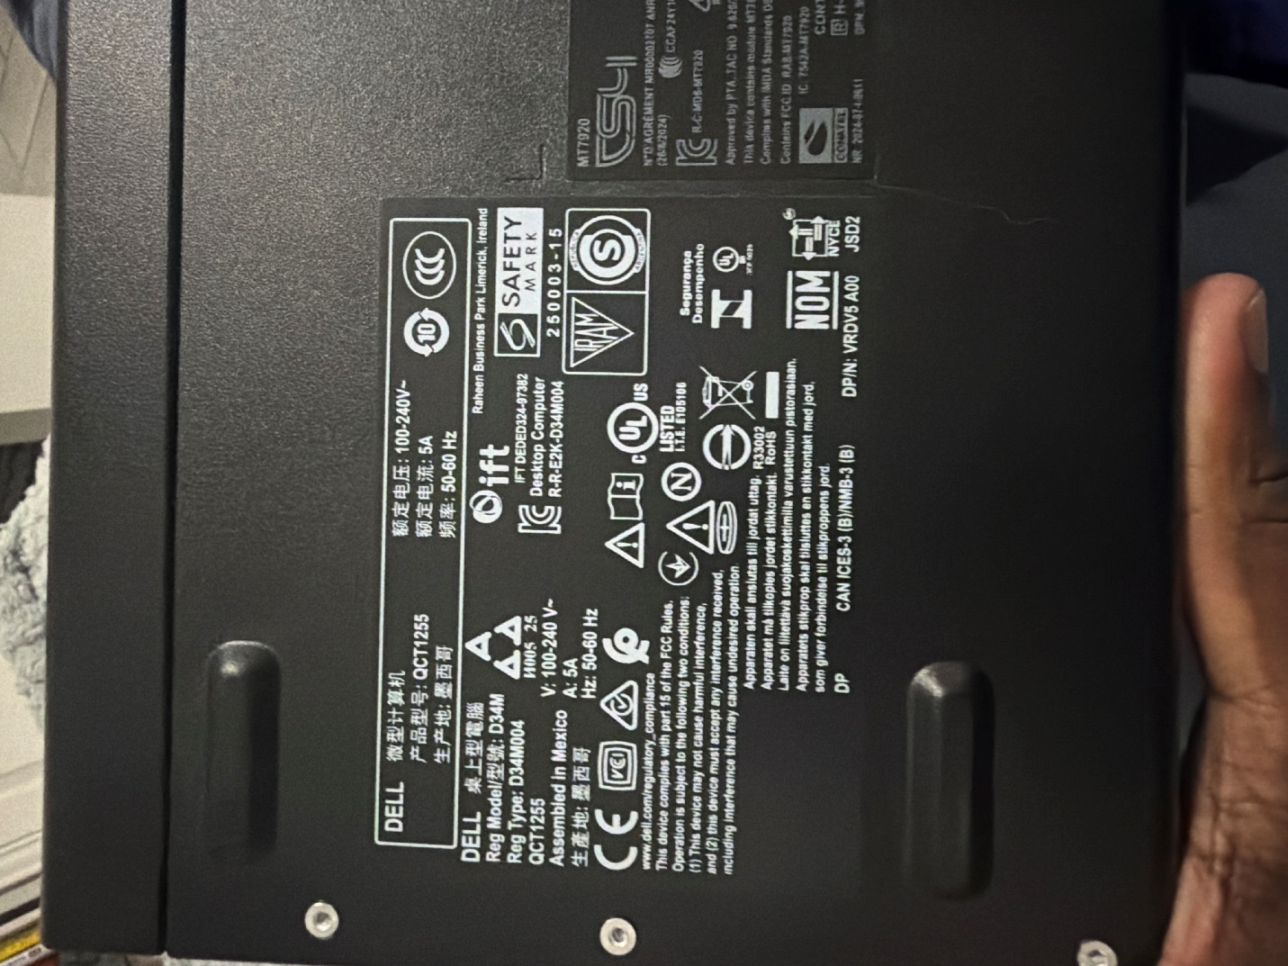

Question 8
7 / 7 pts
Now examine the other cables for the power supply and answer the following: (If it is not specified put N/A for the answer.)
a. Other than the power supply’s, how many cables are there? ________
b. How many SATA power plugs are there? _______
example of SATA power
c. Are any 6-pin power plugs included? (Yes/No)

d. Are there any 8-pin plugs included? (Yes/No)

e. Is the AC plug for the power supply included? (Yes/No)

Your Answer:
a. Number of PSU cables other than AC — 3
b. SATA power plugs — 1
c. 6-pin PCIe plugs — No
d. 8-pin PCIe plugs — No
e. AC plug included — Yes

Question 9
7 / 7 pts
Part 5
CPU Installation:
- Collect your motherboard in it's case and CPU. Keep the CPU close by.
- Place all items on a clear and clean workspace. Make sure you have your tools (Philips screwdriver) nearby in case you need them.
- Place the motherboard in the center of the workspace nearest to you.
- Place the motherboard with the CPU socket toward you.
- Make sure the CPU retainer is open by unhooking and lifting the lever next to the socket. Do not touch the cover until the lever is all the way open.
- Now pick up the CPU. Be careful not to touch any contacts on the CPU when doing this. Grip by the edges only. Do not drop it hard onto the socket or you may damage the pins.
If you are using an Intel CPU, use the notches on either side of the CPU package to align it into the socket. It should lie flat in the socket. If it doesn’t, lift and try a different direction or try to realign it. DO NOT Force the CPU into the Socket.
or
If you are using a AMD CPU align the CPU using the gold triangular pointer on the CPU with the triangle on the metal part of CPU socket holder. Remember DO NOT force the CPU into the socket. It should lay flat inside the socket very easily. If it does not, make sure that you have aligned it correctly or that the socket lever is all the way up.
Do you have an Intel or an AMD CPU? ________
Your Answer:
AMD

Question 10
7 / 7 pts
7. Now lower the socket lever. There should be a little resistance as the CPU is held in place. Lower the lever all the way, and if applicable hook it under the retaining cover on Intel CPUs (make sure the holder goes under the holding tab for the CPUs metal lever tab, the CPU should be held firmly in place. It should not be loose.)
8. Now collect the included heat sink and fan. You should have a tube of paste sent to you by CIAT. Apply a small dot of paste in the center of the CPU facing then proceed to install the Fan/Heatsink.
9. Find the 3 or 4 pin fan power-plug for the heatsink/fan and find the CPU fan 3 or 4 pin plug on the motherboard. Use the guides on the plug to align correctly to connect them. (Consult your pictures or notes if you are unsure where this is.)
10. Make sure the power wires for the fan do not prevent the CPU fan from spinning. If they do, then undo the wire from the clips holding the CPU fan wire until you can clear the fan.
Take a picture with a phone or camera of your finished handy work.
Use the Insert > Image > Upload Image then choose the picture you saved.
Your Answer:
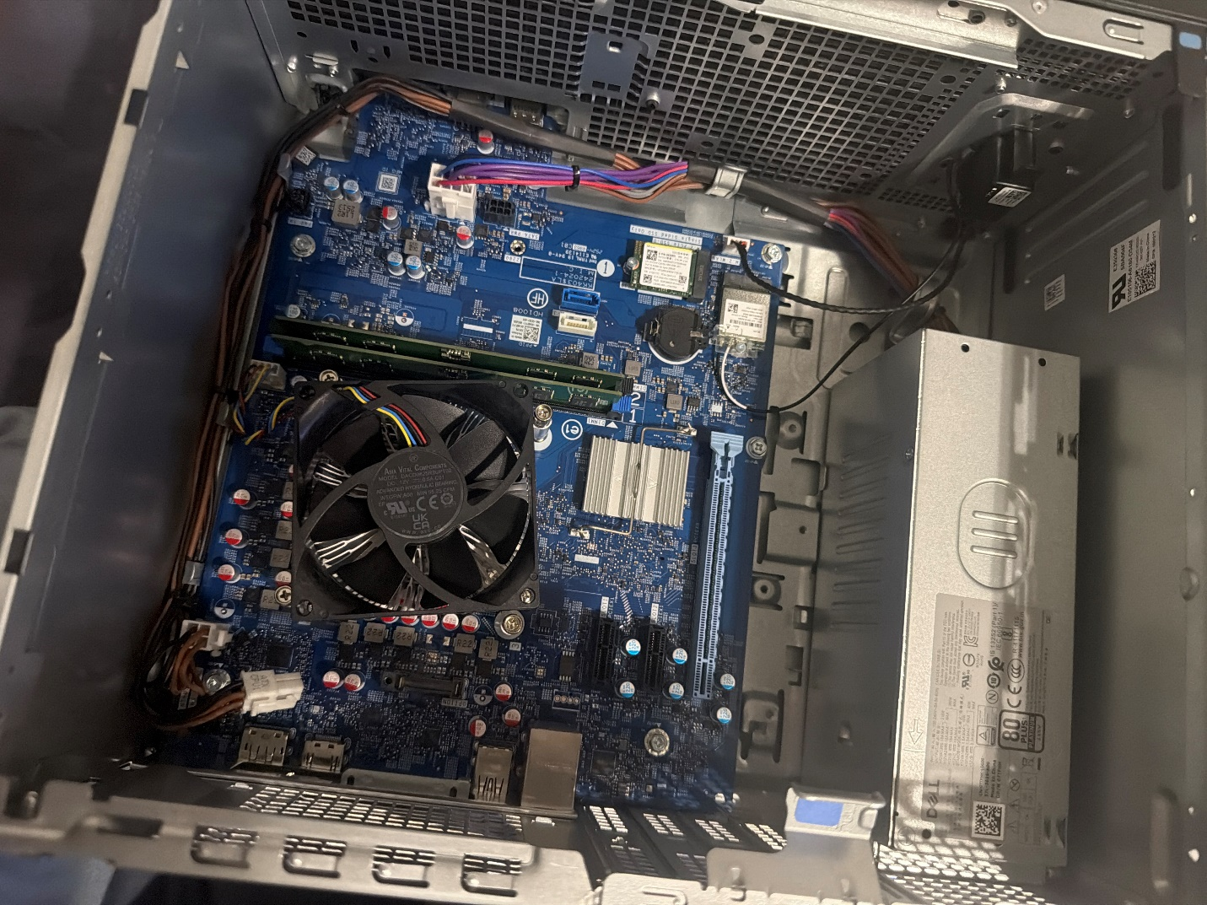

Question 11
7 / 7 pts
Part 6
Installing the RAM:
Collect the motherboard and memory stick(s) that were removed from you Dell PC.
- Clear a flat clean workspace for this exercise. Keep the Philips screwdriver from CIAT nearby in case you need it.
- Place the case on a non-conductive surface in the middle of the workspace within a comfortable reach.
- Obtain the RAM sticks that were in your Dell PC and place them within reach. You are now ready to start the install.
- Make sure to look at your notes or pictures to find the optimal way to install the RAM sticks in a (Dual-Channel configuration if you have two RAM sticks) or (A single-channel configuration if you have only 1 stick of RAM).
What RAM slots on your motherboard would RAM need to be installed into to configure it for Dual-channel access? ________________
Your Answer:
DIMM A1 and DIMM B1 (the two slots closest to the CPU).

Question 12
7 / 7 pts
5. Be careful to handle the RAM by only touching the edges while not touching any of the gold or copper contacts. The contacts are ESD sensitive, so be sure not to touch them under any circumstance.

6. Open the clips on the RAM banks you intend to install the sticks in. The RAM stick will only install in one direction. If the gold/copper contacts are still visible, then remove and make sure you are installing it in the right direction. The RAM stick should sit flush in the RAM slot. If the RAM sticks provide too much resistance, please make sure it is in the right direction. Close the clip on the RAM slot. Not all boards will have 4 RAM slots some may only have 2.
Which slot(s) did you install your RAM in? ______
Your Answer:
DiMM1 & DiMM2

Question 13
7 / 7 pts
Take a picture of the installed DIMM(s) with a phone or camera and upload to the CANVAS question that corresponds to this step. Use the Insert > Image > Upload Image then choose the picture you saved.
Your Answer:
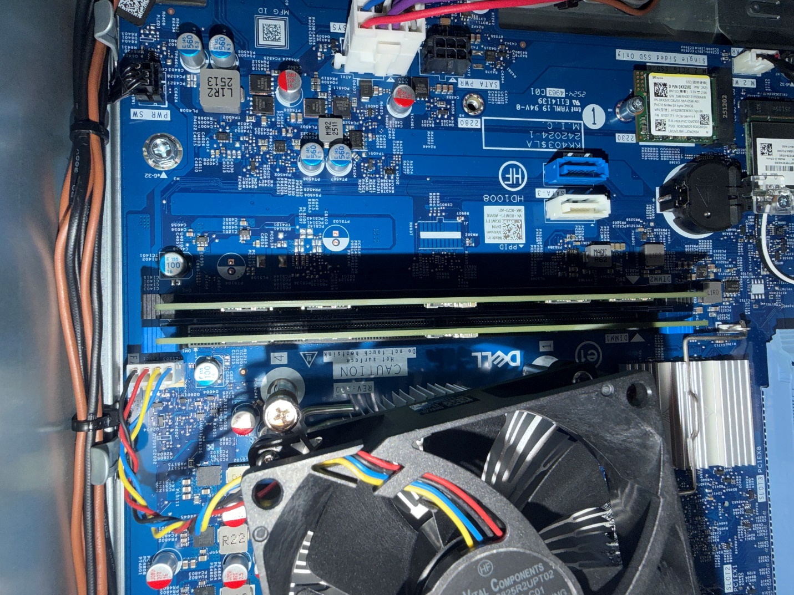

7. Now take and place your computer in a safe place until you use it in your next lab.
Quiz Score: 100 out of 100

