Week 3 - Hands On Exercise 06

Score for this attempt: 100 out of 100
Submitted Nov 22 at 12:37pm
This attempt took 272 minutes.

Question 1
9 / 9 pts
Please make sure to read and complete the entire set of steps before answering the question for each section.
Setup:
Log into your laptop or desktop (preferably the CIAT provided desktop system). Make sure you have one of the following web browsers and that it is operational: Chrome, Firefox, or Edge.
Lab Steps:
Part 1
Internet Speed and Connectivity
In today’s modern world it is critical that a network connection to the Internet is available as many operations and services rely on it services. You might even say that an Internet connection is almost as essential as water or electricity. In this lab we will explore what things are connected to supporting an Internet connection and making sure it works properly.
Often, we are told that if we simply pay a certain amount per month, by Internet Service Providers (ISPs), we can obtain a certain upload and download speed. But how do we know if we are really getting what we are paying for?
- Obtain the speed (upload and download) that your current ISP says you should be getting. Also, note the language. Do they say you are guaranteed this speed, or does it say up to a certain speed?
- Go to the following website https://www.speedtest.net/Links to an external site.

3. Make sure that the server next to the globe icon is set to a location near to your current location. If not select the change server and select one closer to your location.

4. Once you either are ok with the server chosen or have changed it to one that is closer to your location then click on the GO icon and wait for the test to complete.
Once the test has completed, examine the results. Does it match up with what you expected? Take a screenshot of the results.
Use the Insert > Image >Upload Image and choose the picture you saved.
Example:

Your Answer:
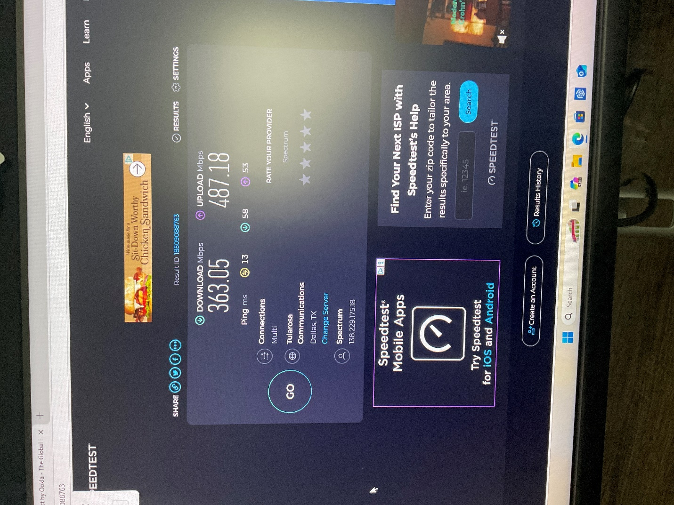

Question 2
9 / 9 pts
5. Now go to the task bar search box and type in CMD. Select the “Run as administrator” option.
6. If a confirmation dialog box appears click “Yes”.
7. Type nslookup www.google.com and press enter. Note the results. Write down the address with four sections with dots in between them under the Name: www.google.com section of the results.

Nslookup is a command that queries something called a DNS (Domain Name) server. It lets us see what TCP/IP addresses are connected to Internet names and must function in order for an Internet connection to work properly, otherwise we would have to know the TCP/IP addresses of every place we wanted to go on the Internet.
8. Now type ping <the address you got from Step 7> and press enter. Note the results.
Take a screenshot of the results from the nslookup command to the ping command.
Use the Insert > Image >Upload Image and choose the picture you saved.

Your Answer:
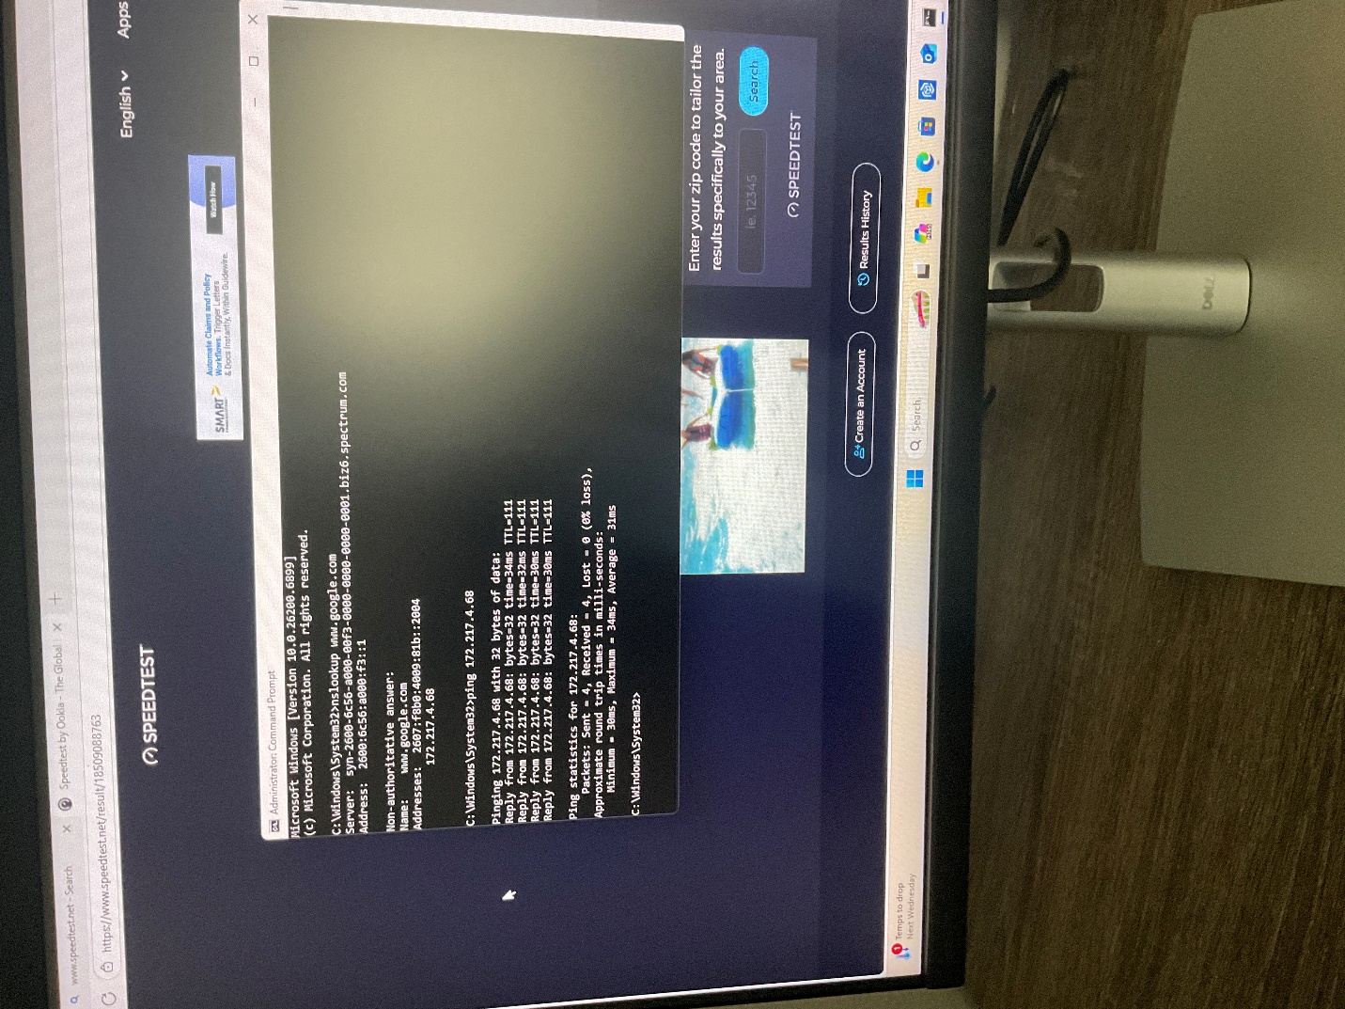

Question 3
9 / 9 pts
9. Now type tracert <the address you got from Step 7> and press enter. Note the results. See an example below:
Now Take a screenshot of the results of the tracert command. What does Part 1 steps 5 through 9 prove about our Internet connection?
Use the Insert > Image >Upload Image and choose the picture you saved.

Your Answer:
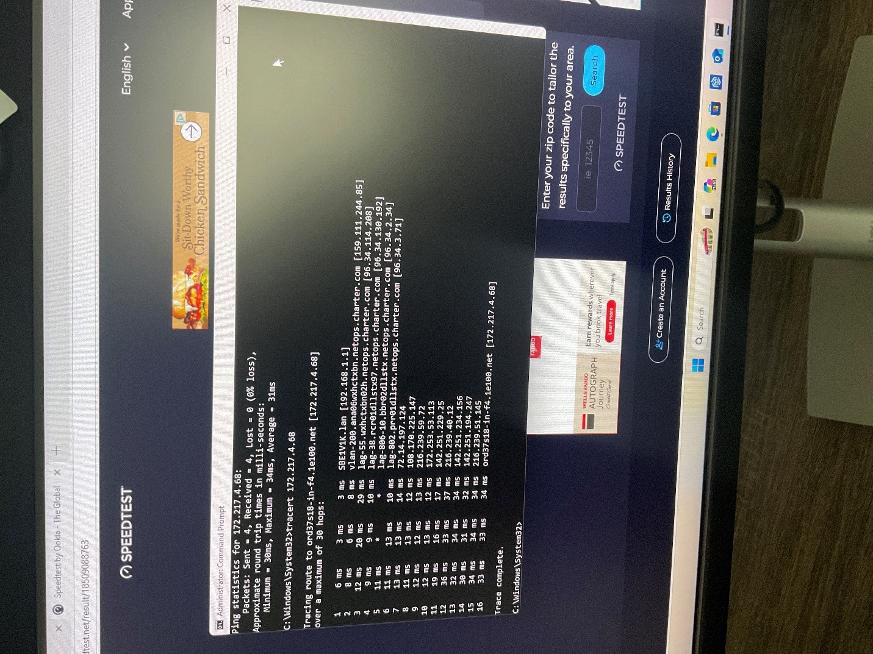

Question 4
9 / 9 pts
10. Now close the command window.
Part 2
Examining TCP/IP Ports
In this part we are going to examine how to tell what TCP/IP ports are open on our system and how to see this information using netstat and prtqry.
1. For this part download PortQry.exe to your system using this link: https://www.microsoft.com/en-us/download/details.aspx?id=17148Links to an external site.
(Note: If you prefer the file can be found in the Canvas File link under the Software folder instead.): PortQryV2.exeDownload PortQryV2.exe
2. Once downloaded go to the downloads folder and click on the exe file and double click it. You should get a dialog like this:

3. Click on the “Yes” button.
4. You should now see this dialog:

5. Click the “Unzip” button.
6. If it worked you should then get this dialog:

7. Click OK. Then click the “Close” button.
8. Open a command-line by typing CMD in the search next to the Windows Start Menu. Then select the “Run as administrator” to start a command line window. If you don’t the next few commands will not execute properly.
9. Select the “Yes” button when the dialog box appears.
10. Type cd c:\PortQryV2 into the prompt and press enter.

11. Type portqry -n localhost -p TCP -e 80 and press enter.
Take a screenshot of the result. What did this tell you about this port on your system?
Use the Insert > Image >Upload Image and choose the picture you saved.

Your Answer:
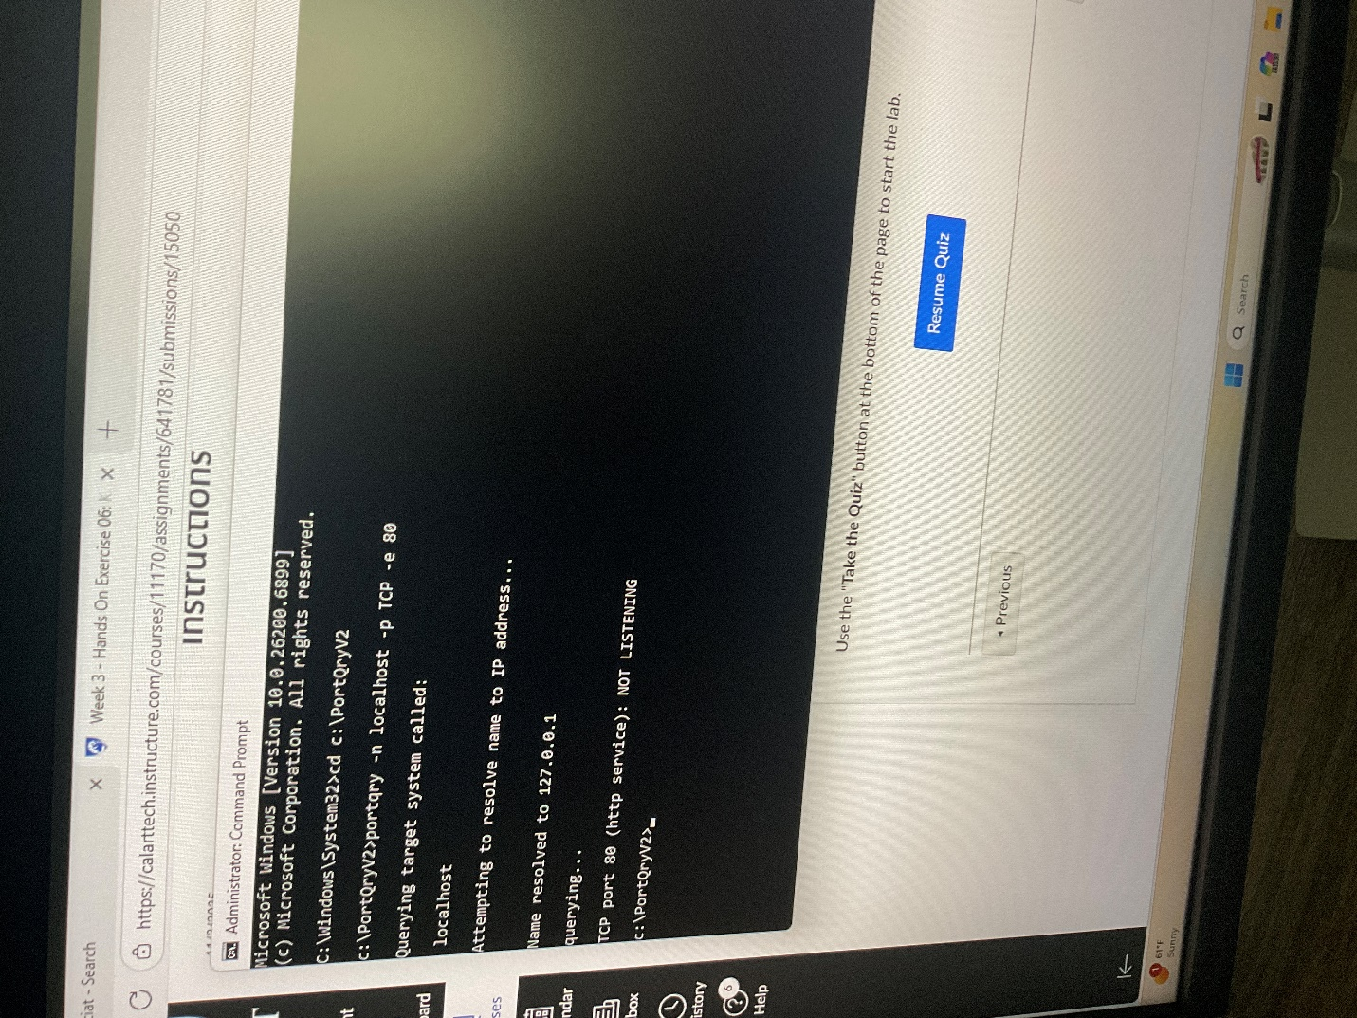

Question 5
9 / 9 pts
12. Type portqry -n localhost -p TCP -e 53 and press enter.
Take a screenshot of the result. What was the name of this port?
Use the Insert > Image >Upload Image and choose the picture you saved.
Your Answer:
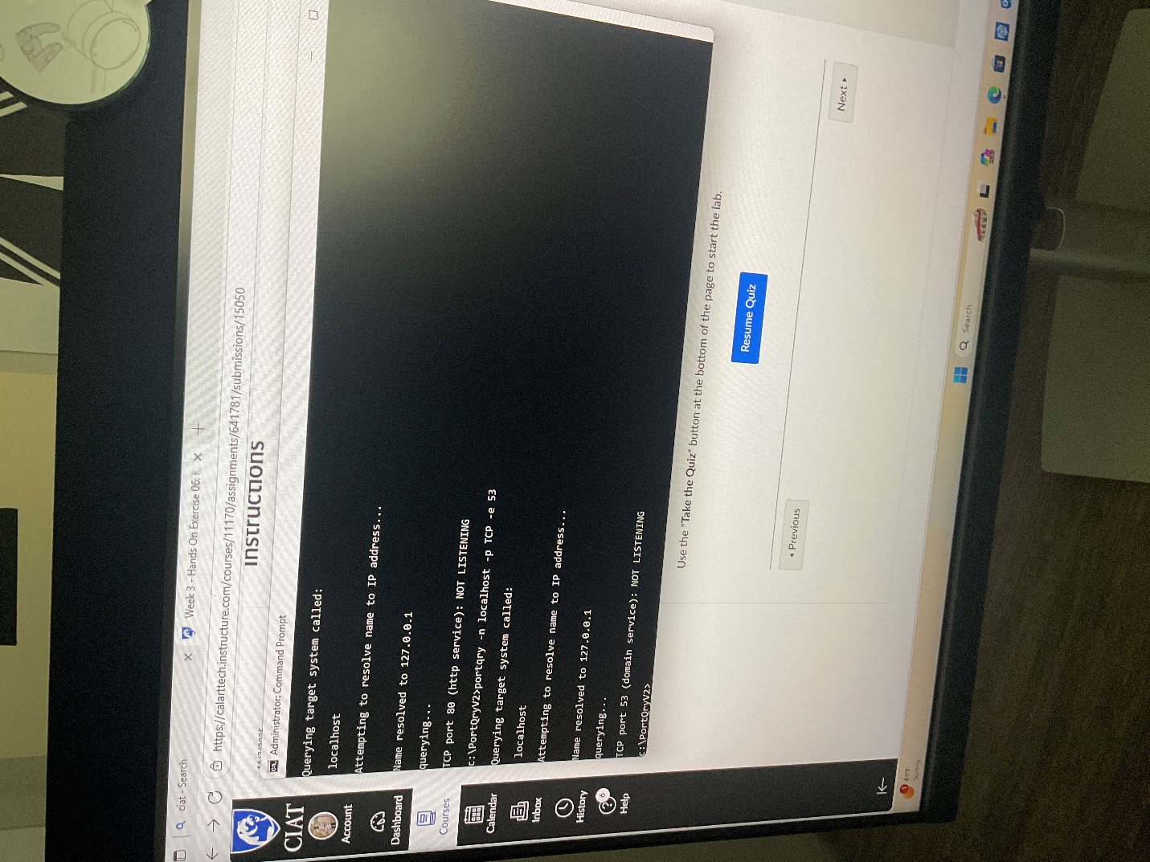

Question 6
9 / 9 pts
13. Type portqry -n localhost -p TCP -o 21,22,443,389 and press enter.
Take a screenshot of the result. How could port query help you remember the services for ports?
Use the Insert > Image >Upload Image and choose the picture you saved.
Your Answer:
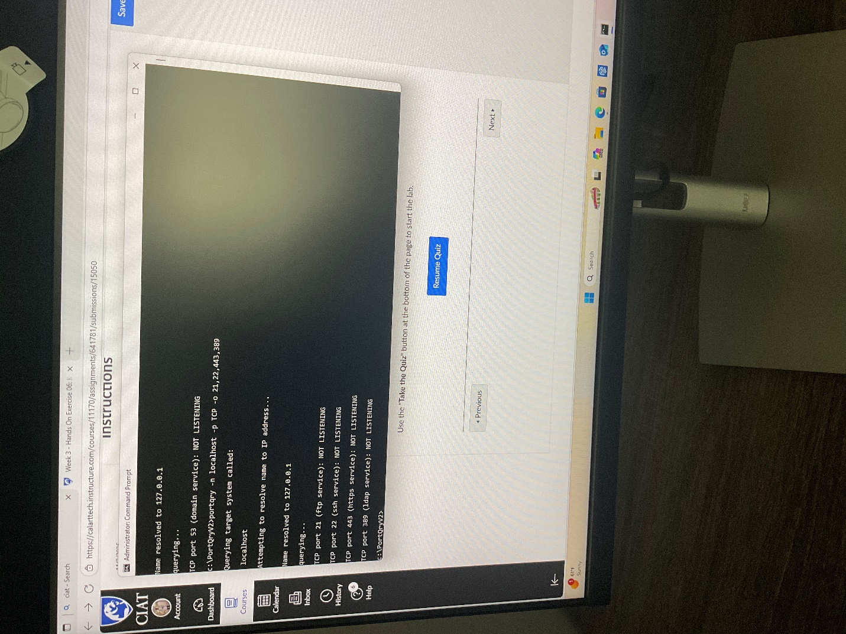

Question 7
9 / 9 pts
14. Now type netstat -p TCP -b and press enter.
Take a screenshot of the result. What information did this give you about your connections?
Use the Insert > Image >Upload Image and choose the picture you saved.
Your Answer:
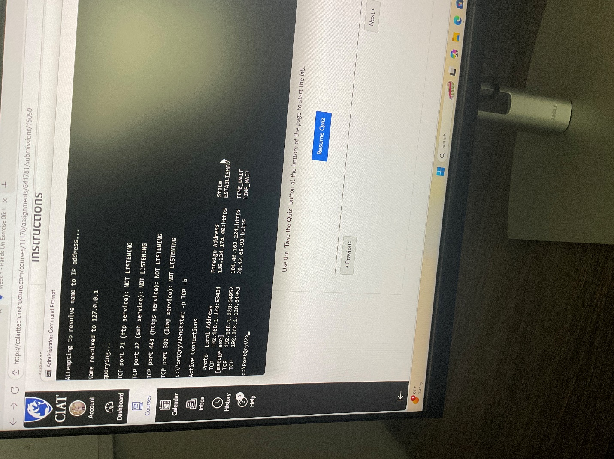

Question 8
9 / 9 pts
Part 3
Using Task Manager to monitor network activity.
We will now look at and observe what network activity looks like by creating some network traffic and seeing at what it looks like in Task manager’s Performance tab.
1. Let’s open a browser and navigate to the following website once more: https://www.speedtest.net/Links to an external site.
2. Now set the browser window aside and open the Task Manager by typing Task Manager in the search tool on the taskbar and then select “Run as administrator”.

3. Select the Performance tab and then find the active Ethernet counter:

4. Now go back to the web browser with the speed test website in it and size the Task Manager and Web browser to be visible side by side. Make sure to note the speed in bits per second before selecting the Go link on the web page.

5. Select the Go link on the page to start the test.
Take a screenshot during the test. Note what happened during the test. Did the Task Manager measurements match the ones on the website speed test? How do you think this might be used when you are investigating a connectivity issue?
Use the Insert > Image >Upload Image and choose the picture you saved.

Your Answer:
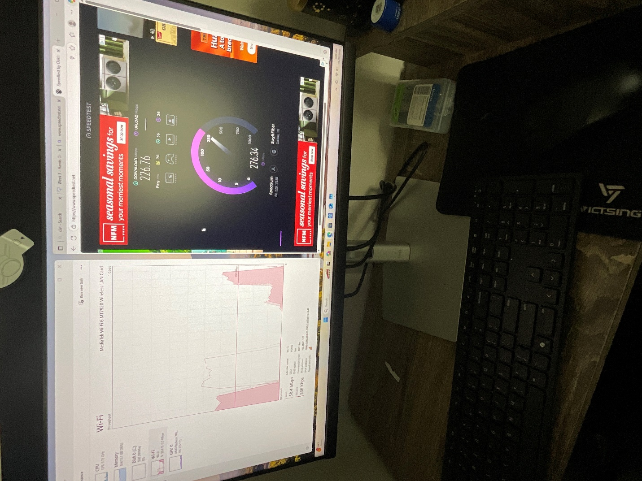

Question 9
9 / 9 pts
Part 4
Identify your Residential Internet Gateway.
Now we will identify just how we are physically connected to the Internet. Everyone who has an Internet connection will also have a device in their home that provides this connection. It is time to identify what the device is, what it looks like, and the connections it is capable of.
- Search your home, apartment, or room for the device you use to connect to the Internet. If you are unsure you can ask your ISP or someone else to help you identify it. Be sure to look in closets and out of the way spaces if it is not readily and easily seen.
- The device could look like some of the examples below:

3. Examine the device to see what ports and connections it might have. Be careful not to disconnect any cables or power cords from the device.
Take a picture of the front and back of the router and upload to this question in Canvas. Identify as many networking ports as you can. How many RJ-45 (8P8C) ports does it have? Are there any other types of ports visible? How can you find out if it is a WiFi capable router gateway?
Use the Insert > Image >Upload Image and choose the picture you saved.
Example only:

Your Answer:
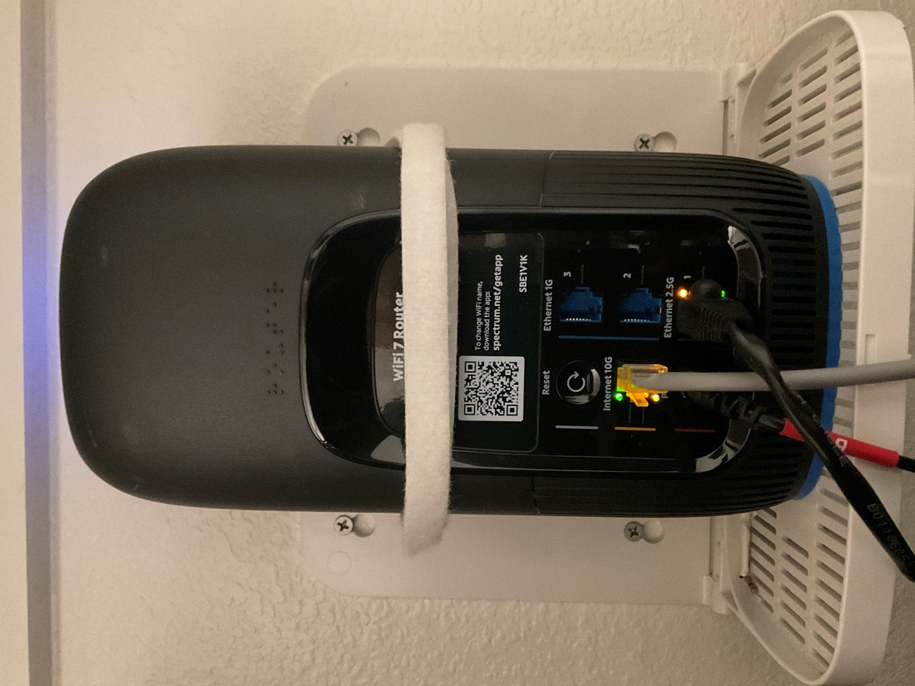

Question 10
9 / 9 pts
Part 5
Examine the Network Card Driver.
Now for the final piece of the puzzle in the chain of connection from your device to the network and Internet. Remember that just because you have a network connection, does not necessarily mean that you have an Internet connection, but it is crucial that you have a working network connection before you can have a working Internet connection. One of these thing that will need to be present as a part of your device (Desktop or Laptop) is a network driver for the network interface card that is installed in your system. If it missing or it is the incorrect driver for the interface you are using or the version of OS you are using, you will be unable to connect to the network or Internet.
1. Go to your Systems desktop and right click on the start menu. Click on Device Manager.

2. Now expand the Network Adapters device using the “>” next to the text.

3. Examine the Adapters that are listed. Do any have a ! inside a yellow triangle? Do any have a red X next to their names? If so, the yellow triangle would represent a driver error and could indicate a missing, corrupt, of incorrect driver for the device. If a red X shows up, then it means that the device has been disabled manually or by the system using a program or app. In either case it would mean that the network device is unable to function.
4. See if you can find a device similar to WiFi 6AX and lets right click on it (if you don’t have this connection try to find something similar to the text of “Ethernet Controller” , but don’t use Bluetooth or Virtual Controllers).
5. Now, select the Properties from the context menu.

6. On the properties page select the Driver tab. The click on the Driver Details button.

You should now see the Driver File Details page. Take a screenshot of the Driver Details page.
Use the Insert > Image >Upload Image and choose the picture you saved.
This is an Example:

Your Answer:
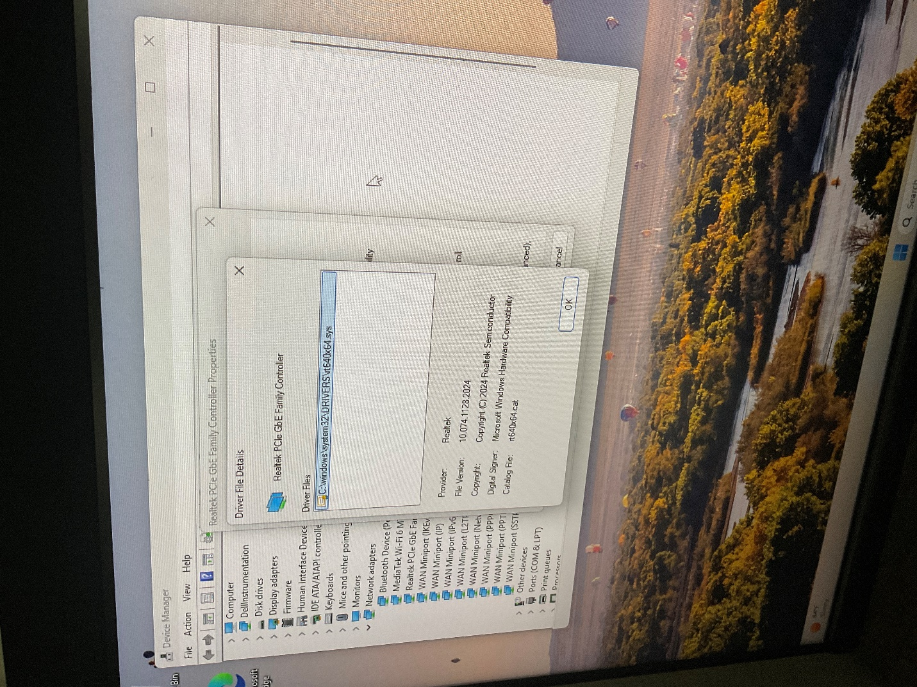

Question 11
10 / 10 pts
7. This would give you the details of the driver and where the driver files were located in the file system.
8. Now click OK. On the network adapter’s properties page select the Update driver.

9. Click on the “Search automatically for drivers”.

Take a screenshot of the results. Did the search process find new or updated drivers?
Use the Insert > Image >Upload Image and choose the picture you saved.
Example:

Your Answer:
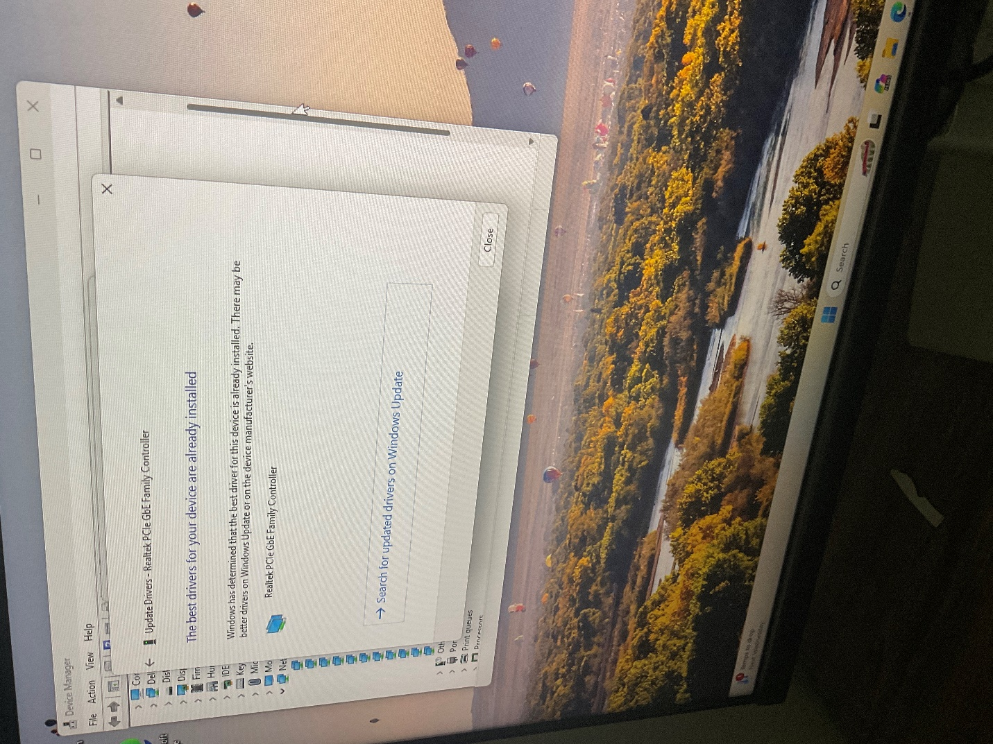

10. Click close and close the remaining windows including Device Manager.

END OF EXERCISE 6
Quiz Score: 100 out of 100

